Route App

Session: 2021

Software Requirements Engineering -SRE

Submitted by:

Muhammad Salman Naeem {2021-SE-04}

Noman Ahmad {2021-SE-24}

Farjad Waseem {2021-SE-56}

Submitted to:

Ma’am. Alina Munir

Department of Computer Science, New Campus

University of Engineering and Technology Lahore, Pakistan

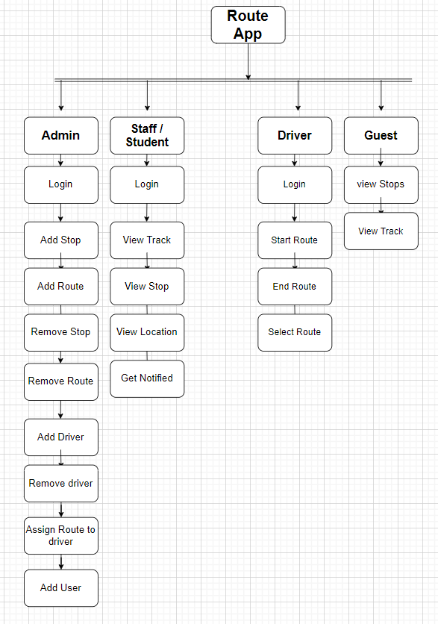

**Vision Statement:**

For students, staff members, and transport officers, who want to check and track their bus route via mobile app. KSK Routes is a bus route tracking app that will provide the facility to students and staff members to track their specific buses and the current location of the bus. Unlike Google Maps, the focus is to provide students and staff members an interactive UI and push notifications in case their route bus has started. Our product will lessen the transport office’s burden of managing everyday student-driver issues and provide students or staff members with effective ways to reach university in case their route is missed.